Introduction

Azure IoT Suite [preconfigured solutions](https://azure.microsoft.com/en-us/documentation/articles/iot-suite-what-are-preconfigured-solutions/) combine multiple Azure IoT services to deliver end-to-end solutions that implement common IoT business scenarios.

This tutorial shows you how to provision the *remote monitoring* preconfigured solution. It also walks you through the basic features of the remote monitoring preconfigured solution.

In order to complete this tutorial, you’ll need an active Azure subscription.

**Note:**

If you don’t have an account, you can create a free trial account in just a couple of minutes. For details, see [Azure Free Trial](http://azure.microsoft.com/pricing/free-trial/).

Provision the remote monitoring preconfigured solution

1. Log on to [azureiotsuite.com](https://www.azureiotsuite.com/) using your Azure account credentials, and click **+** to create a new solution.

**Note:**

If you're having trouble with the permissions required to provision a solution, take a look at [Permissions on the azureiotsuite.com site](https://azure.microsoft.com/en-us/documentation/articles/iot-suite-permissions/) for guidance.

1. Click **Select** on the **Remote monitoring** tile.
2. Enter a **Solution name** for your remote monitoring preconfigured solution.
3. Select the **Region** and **Subscription** you want to use to provision the solution.
4. Click **Create Solution** to begin the provisioning process. This typically takes several minutes to run.

Wait for the provisioning process to complete

1. Click on the tile for your solution with **Provisioning** status.
2. Notice the **Provisioning states** as Azure services are deployed in your Azure subscription.
3. Once provisioning completes, the status changes to **Ready**.
4. Click on the tile and you'll see the details of your solution in the right-hand pane.

Are there details you'd expect to see that aren't listed for your solution? Give us feature suggestions on [User Voice](https://feedback.azure.com/forums/321918-azure-iot).

View remote monitoring solution dashboard

The solution dashboard enables you to manage the deployed solution. For example, you can view telemetry, add devices, and configure rules.

1. When the provisioning is complete and the tile for your preconfigured solution indicates **Ready**, click **Launch** to open your remote monitoring solution portal in a new tab.

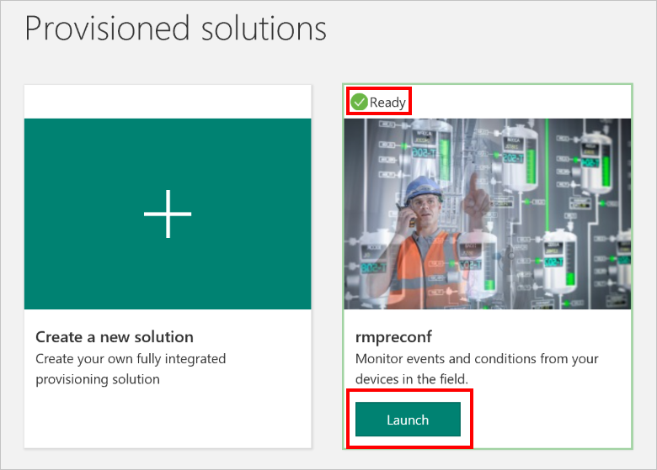

1. By default, the solution portal shows the *solution dashboard*. You can select other views using the left-hand menu.

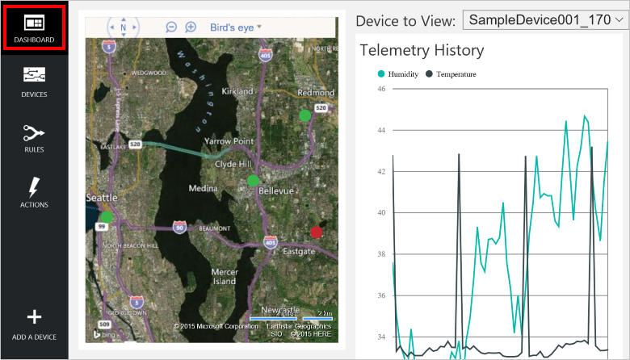

View solution device list

The device list shows all the registered devices in the solution. You view and edit device metadata, add or remove devices, and send commands to devices.

1. Click **Devices** in the left-hand menu to show the *device list* for this solution.

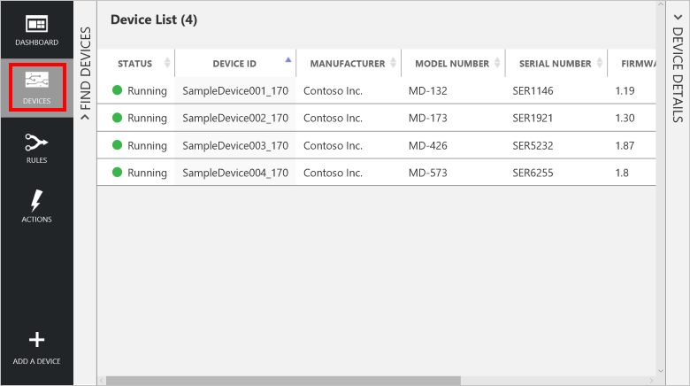

1. The device list shows that there are four simulated devices created by the provisioning process.
2. Click on a device in the device list to view the device details.

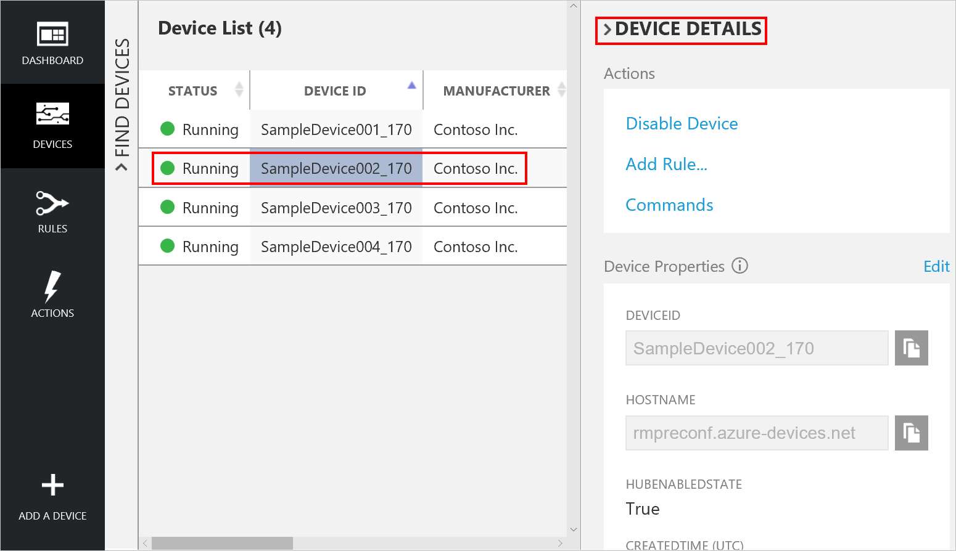

Send a command to a device

The device details pane shows all of the commands that the device supports and enables you to send commands to specific devices.

1. Click **Commands** in the device details pane for the selected device.

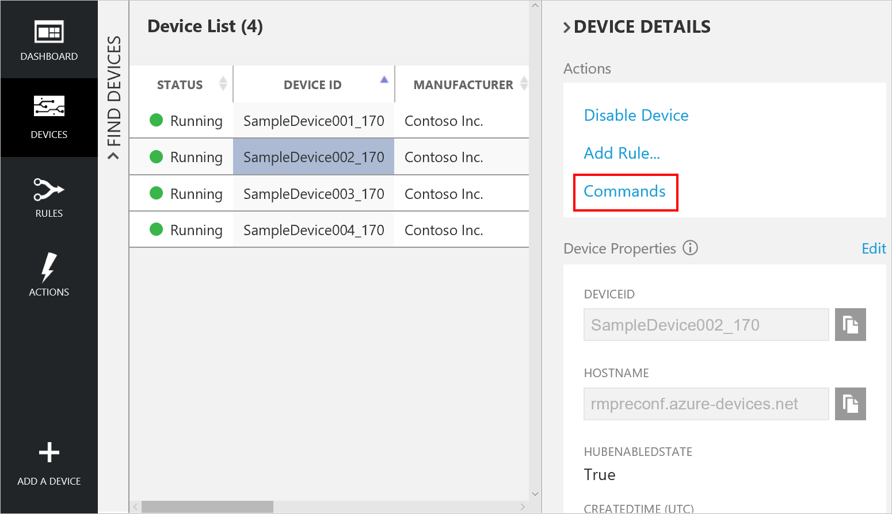

1. Select **PingDevice** from the command list.
2. Click **Send Command**.
3. You can see the status of the command in the command history.

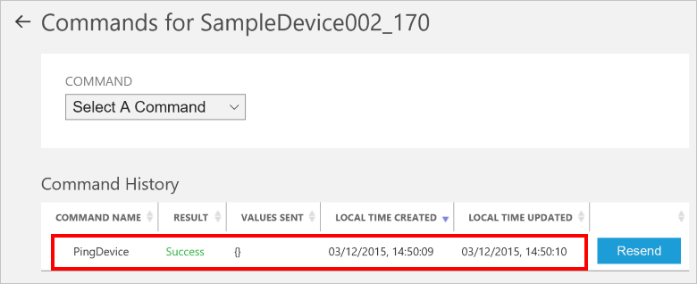

Add a new simulated device

1. Navigate back to the device list.
2. Click **+ Add A Device** in the bottom left corner to add a new device.

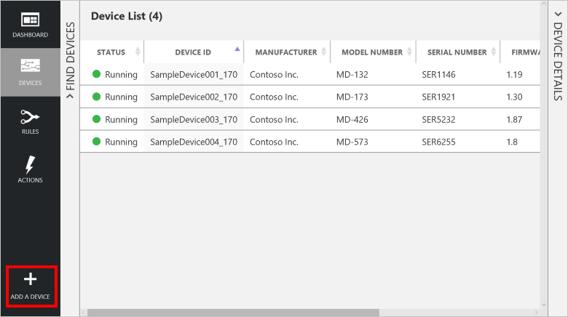

1. Click **Add New** on the **Simulated Device** tile.

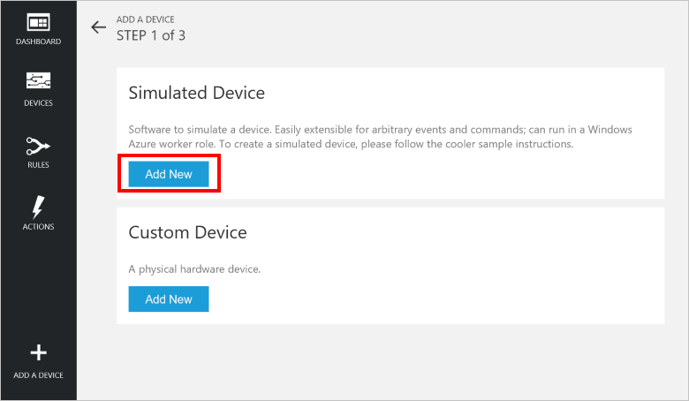

1. Select **Let me define my own Device ID**, and enter a unique device ID name such as **mydevice_01**.
2. Click **Create**.

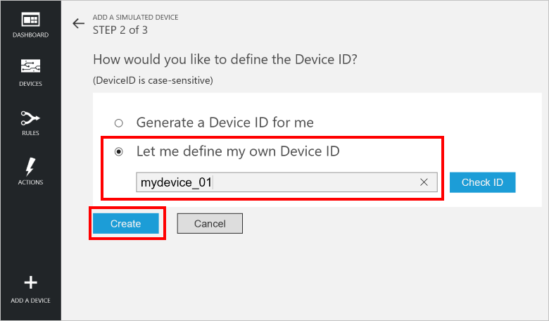

1. In step 3 of **Add a simulated device** click **Done** to return to the device list.
2. You can view your device **Running** in the device list.

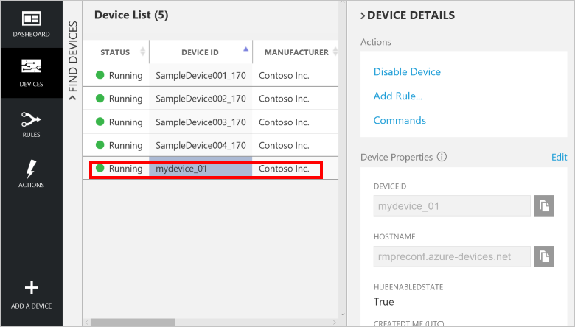

Add a new physical device

To add a new physical device to the solution, see [Connect your device to the IoT Suite remote monitoring preconfigured solution](https://azure.microsoft.com/en-us/documentation/articles/iot-suite-connecting-devices/).

View and edit solution rules

The preconfigured solution provisions two rules for SampleDevice001. The rules notify you on the **Alarm History** tile in the dashboard when the temperature or humidity values exceed a threshold.

1. Return to the solution dashboard and view the **Alarm History** tile.

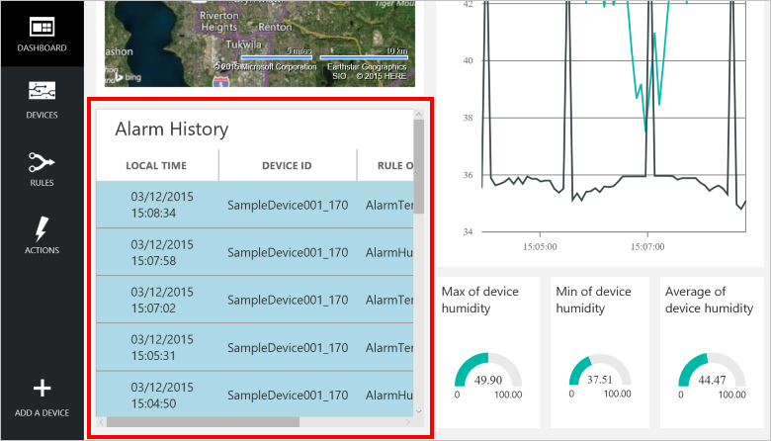

1. The rule **AlarmTemp** triggers these alarms.
2. Click **Rules** in the left-hand menu to view the rules for this solution.

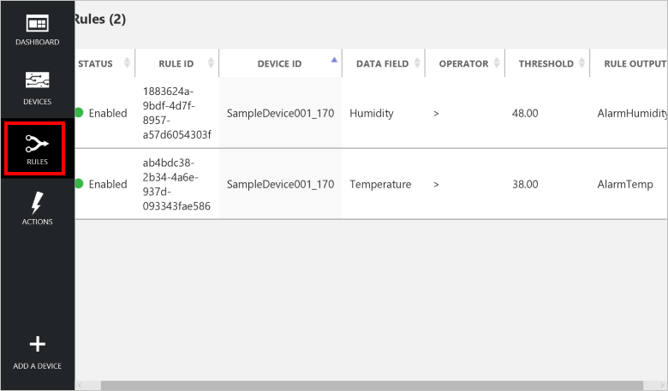

1. Click the **Temperature** rule in the rules list to view the rule properties.
2. To modify a rule, click **Edit** in the rule properties pane.

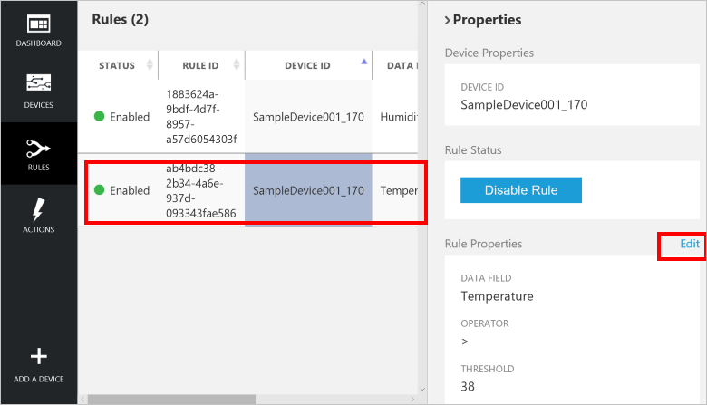

1. Change the **Threshold** to 30 and keep all other properties the same.
2. Click **Save and View Rules**.

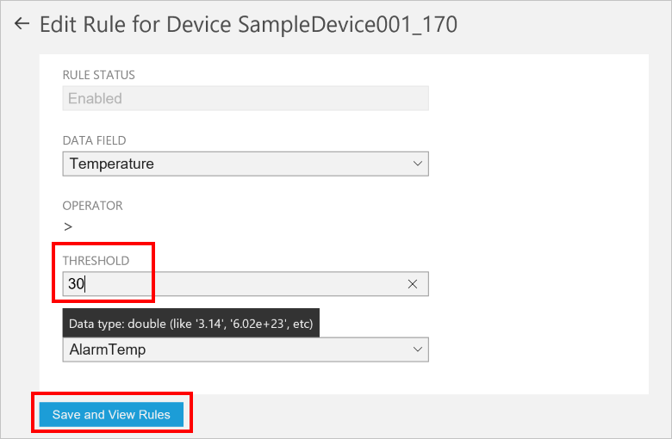

1. Return to the **Alarm History** table in the **Solution Dashboard** and observe the change in behavior that results from the updated rule.

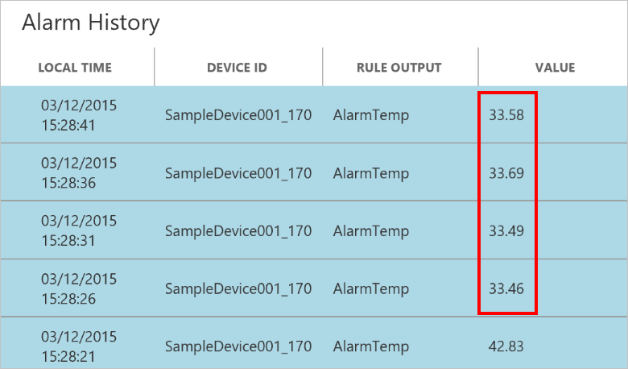

When you are done, you can delete the preconfigured solution from your Azure subscription on the [azureiotsuite.com](https://www.azureiotsuite.com/) site - this enables you to easily delete all the resources that were provisioned when you created the preconfigured solution.